Alexie DaCosta

CSCI362: Databases and Datamining

Professor Kumar Ramansenthil

2 July 2025

**Milton Hotels Database Management System (DBMS)**

**Question 1: Assumptions**

1. Multiple guests can have the same address.
2. Only one guest will check-in for his or her entire party. Only the person booking the hotel will have his or her information saved.
3. Each booking is limited to one hotel location.
4. Guests can book numerous rooms.
5. A room cannot be double booked.

* ER Diagram Explained: The same room can be booked for different dates, with **rooms** to **roomsbooked** having a one to zero or many relationship. Therefore, **roomsbooked** can have multiple **bookings**, with a many to many relationship.
* Given the relationship between **roomsbooked** and **bookings**, how will double booking be prevented?

The constraint will not be built into the database; rather, it will be enforced in the source code. We will check for room availability before inserting new values.

1. The payment method is card only.
2. Multiple cards can pay for the bill.
3. The bill will be sent out as one cumulative statement at the end of the stay, with all booked rooms charged to one bill.

* ER Diagram Explained: While a **guest** can only have one **bill** per booking, implying a one-to-one relationship, the guest can have multiple bookings and will be billed for each of them, creating a one-to-many relationship.

**Question 2: ER Diagram / Relational Diagram**

**Question 3:**

**Table: GuestAddress**

**Table: Guest**

**Table: HotelLocation**

**Table: Booking**

**Table: Bill**

**Table: Room**

**Table: Transactions**

**View**

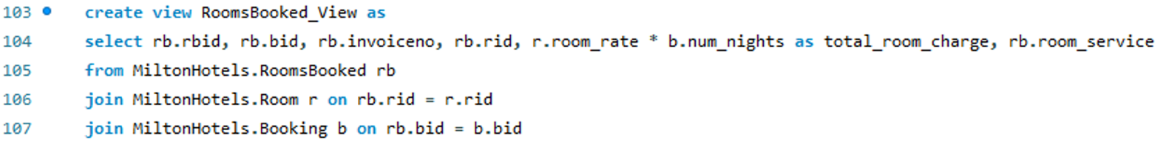

**Question 4: INSERT**

**Table: GuestAddress**

**Table: Guest**

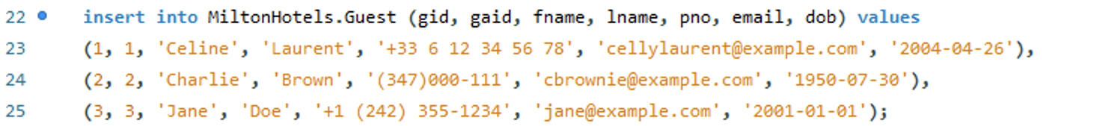

**Table: HotelLocation**

**Table: Booking**

**Table: Bill**

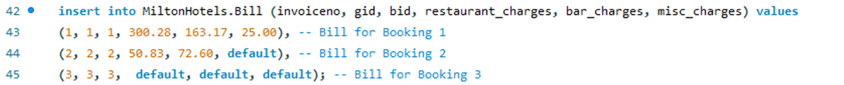

**Table: Room**

**Table: RoomsBooked**

**Table: Transactions**

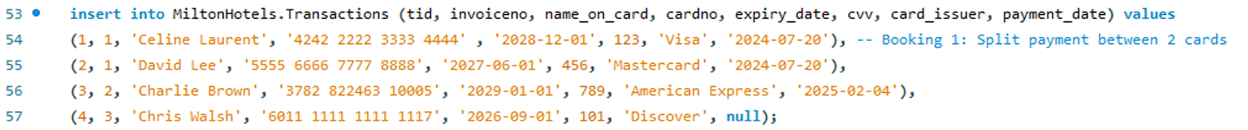

**Question 4: UPDATE**

**Table: GuestAddress**

**Table: Guest**

**Table: HotelLocation**

**Table: Booking**

**Table: Bill**

**Table: Room**

**Table: RoomsBooked**

**Table: Transaction**

**Question 4: DELETE**

**Table: Room**

**Table: HotelLocation**

**Table: RoomsBooked**

**Table: Transactions**

**Table: Bill**

**Table: Booking**

**Table: Guest**

**Table: GuestAddress**

